How to Install XPPen Driver on Windows System
1. Open the webpage and enter: http://www.xp-pen.com, click on the "Driver" section.


- Find your product model, for example: Artist Pro 19 (Gen2).
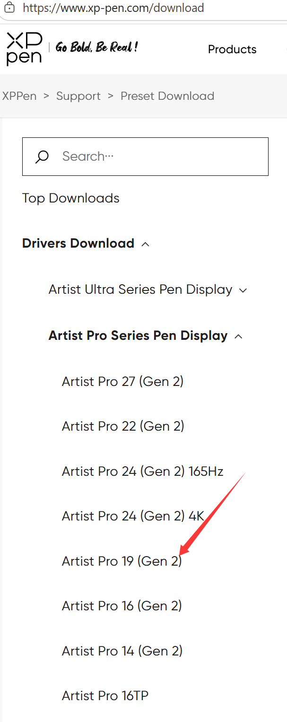
3. Drivers are available for both Windows, Mac, and Linux systems; please select the Windows version.
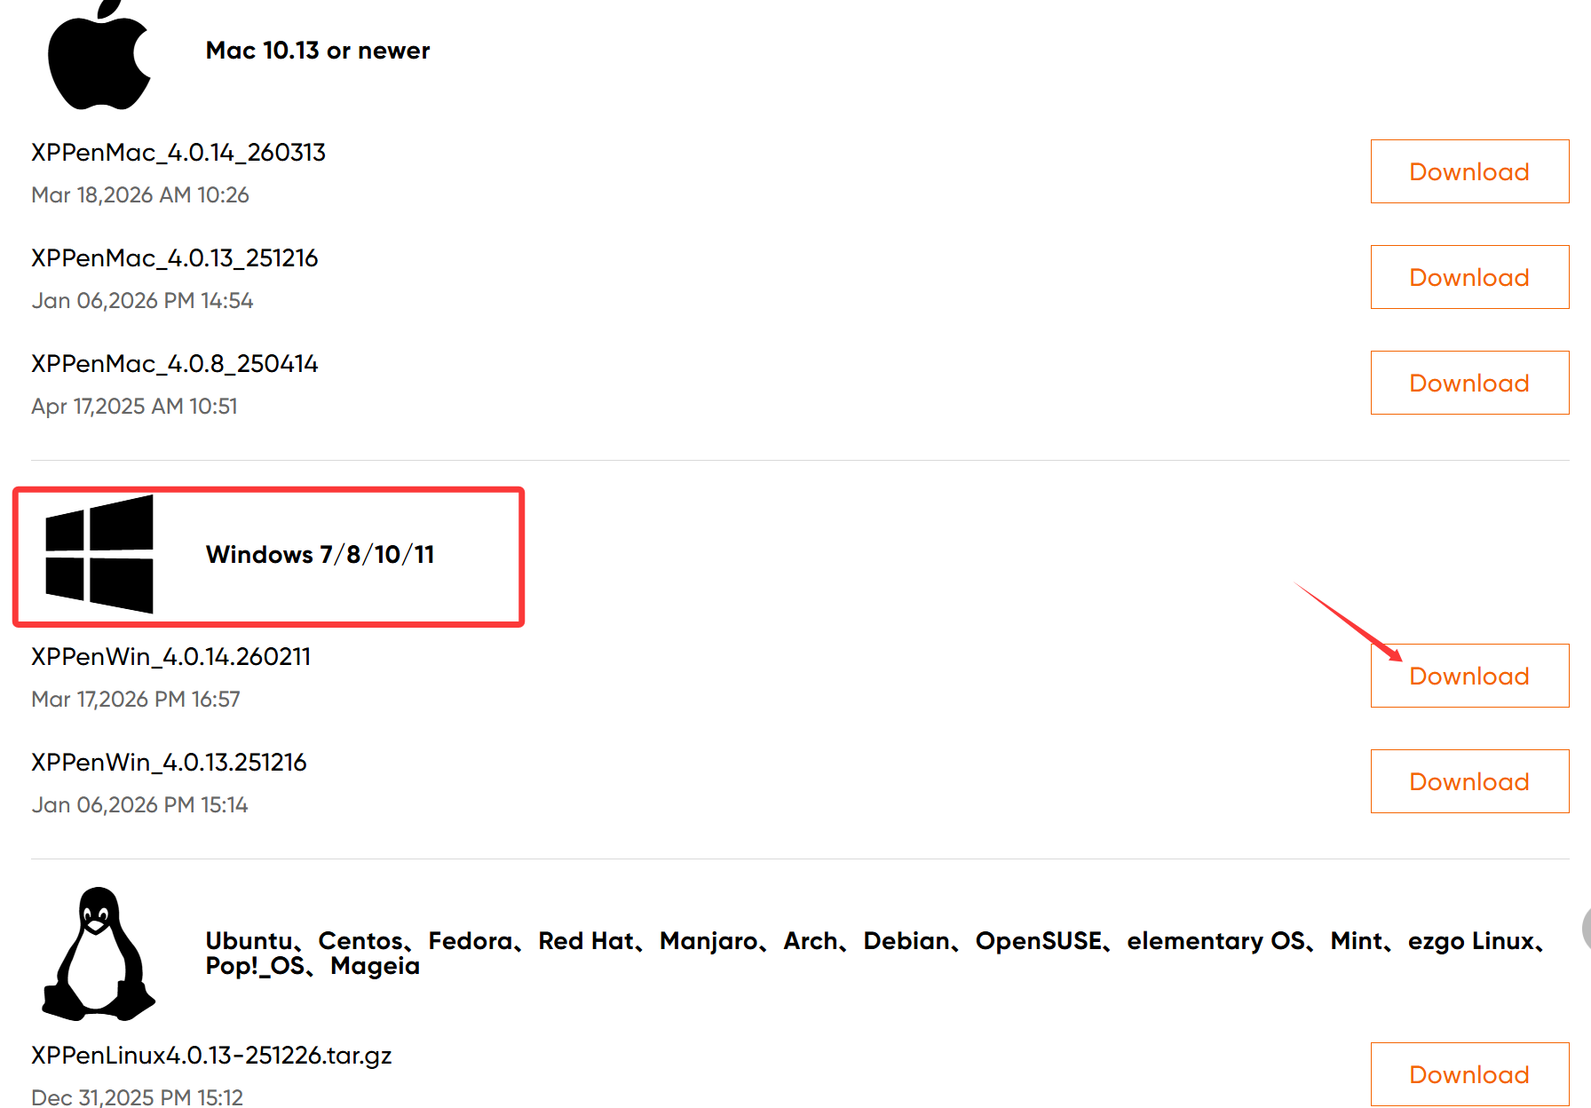
4. After downloading, right-click to extract the folder (Windows 11 can extract ZIP files natively; if your system cannot, you need to install an extraction tool first like 7-zip). When installing the driver, first exit the antivirus software on your computer and then install it with Administrator privileges.
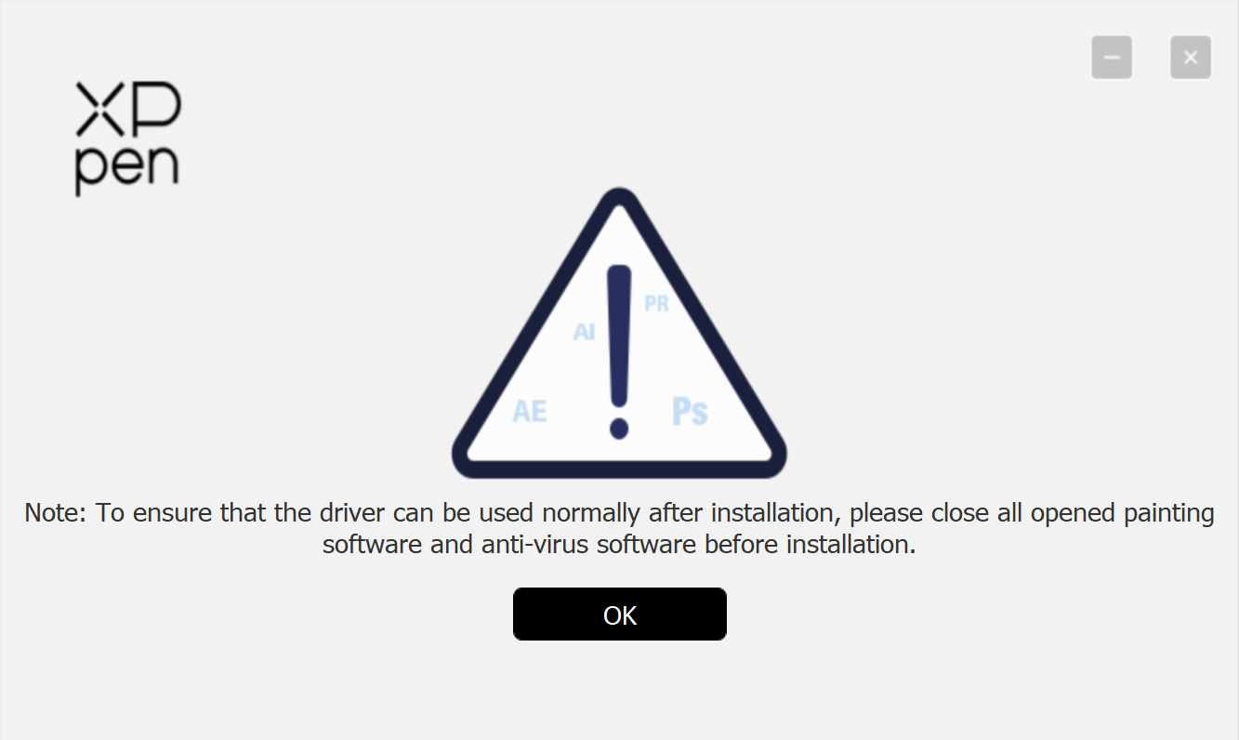
5. After installation, a prompt will appear asking you to click "Restart Now".
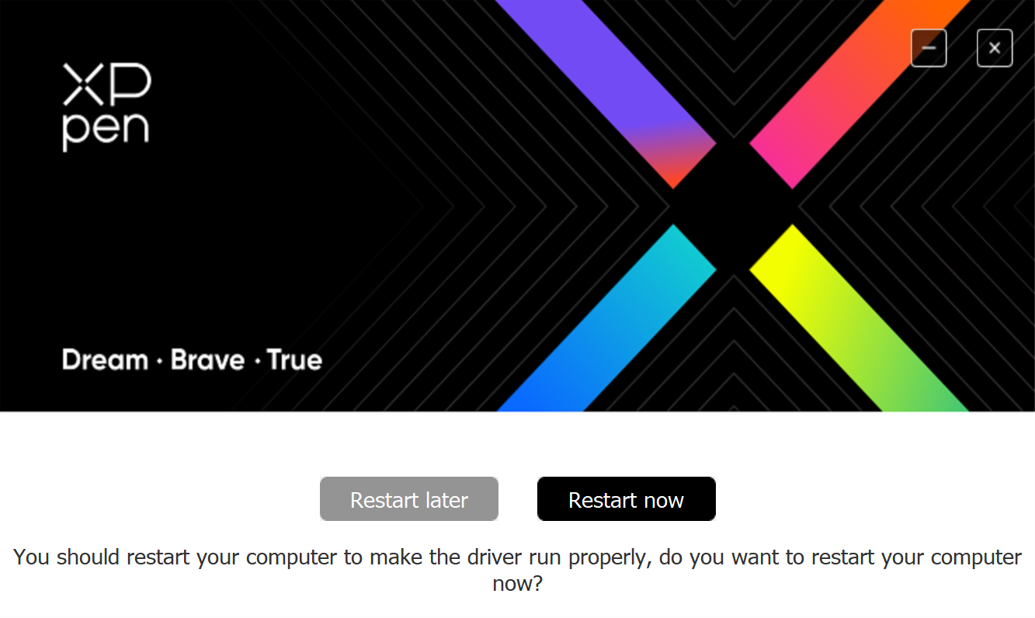
6. After restarting, if the following icon appears on the desktop, it indicates the driver installation is complete.

7. The driver usually starts automatically on system startup. If your system does not, you can double-click the shortcut above to open it.

