How to Artist 10S, 16, 22HD & 22E drivers on Mac OS Mojave (10.14)

- Visit the XP-Pen website driver page and (https://www.xp-pen.com/download/index/cid/25.html), then download and install the latest driver for your operating system.
- Click on the driver to install. An “Unidentified developer” error message will pop up, click the OK button.

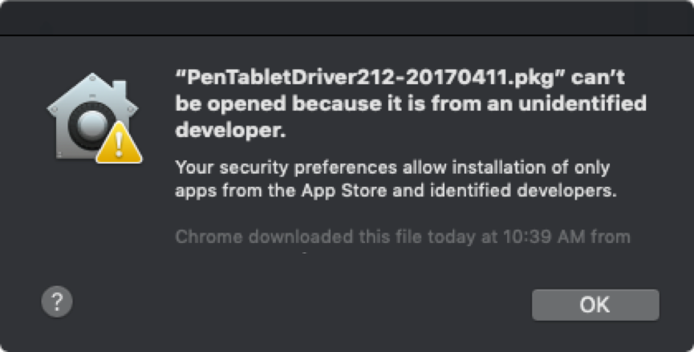

- Open “System Preferences” – “Security & Privacy”.
- On the General tab, click “Open Anyway” and install the driver.

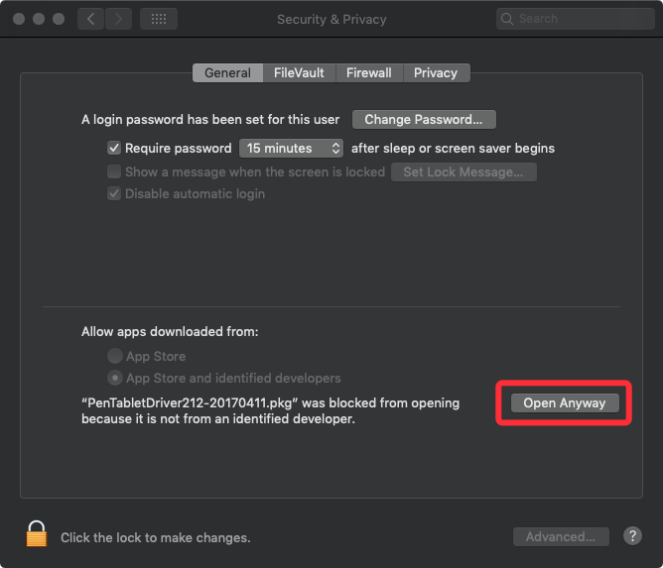

- When installation is complete, the tablet setting will open automatically. Close it.
- Open “System Preferences” – “Security & Privacy” – “Privacy”.
- On the “Accessibility” tab, click “Unlock” first then click the “+” button.

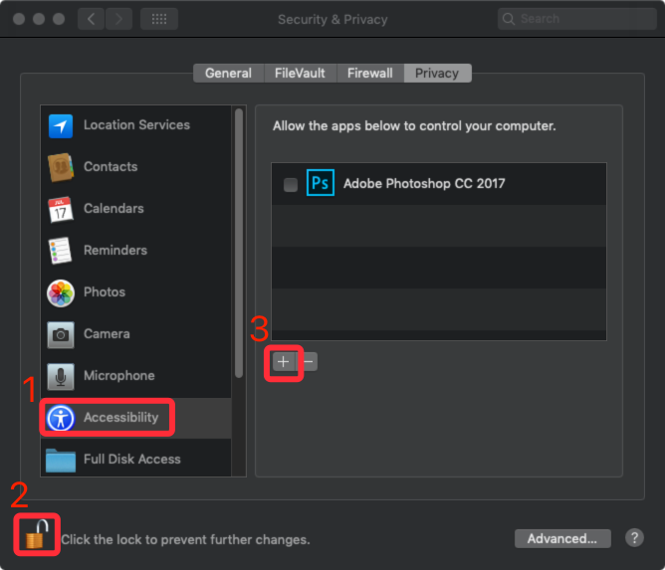

- Go to “Application” – “Touch Tablet” folder then choose “TabletSetting” and then click “Open”.

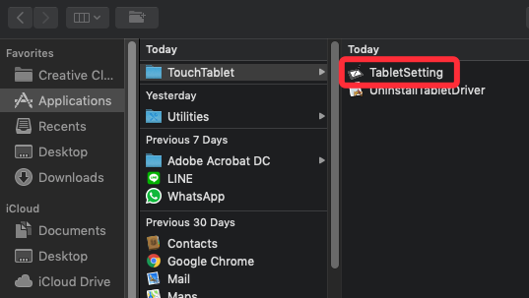

- Make sure “TabletSetting” is enabled.

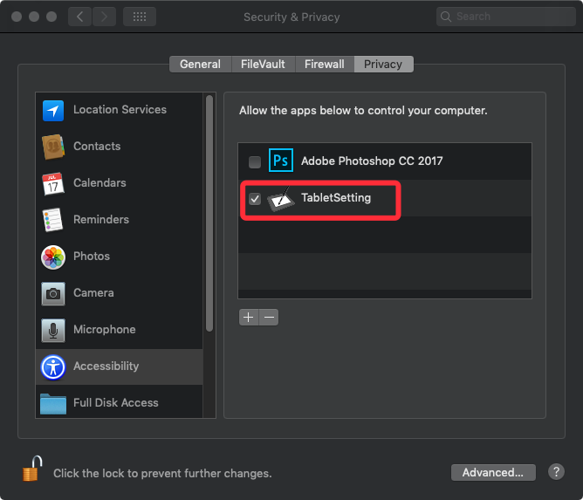

- Click “+” button again.
- Go to “Macintosh HD” – “Library” – “Application Support” – “TouchTablet” folder then choose “TouchTabletDriver” and “Open”.

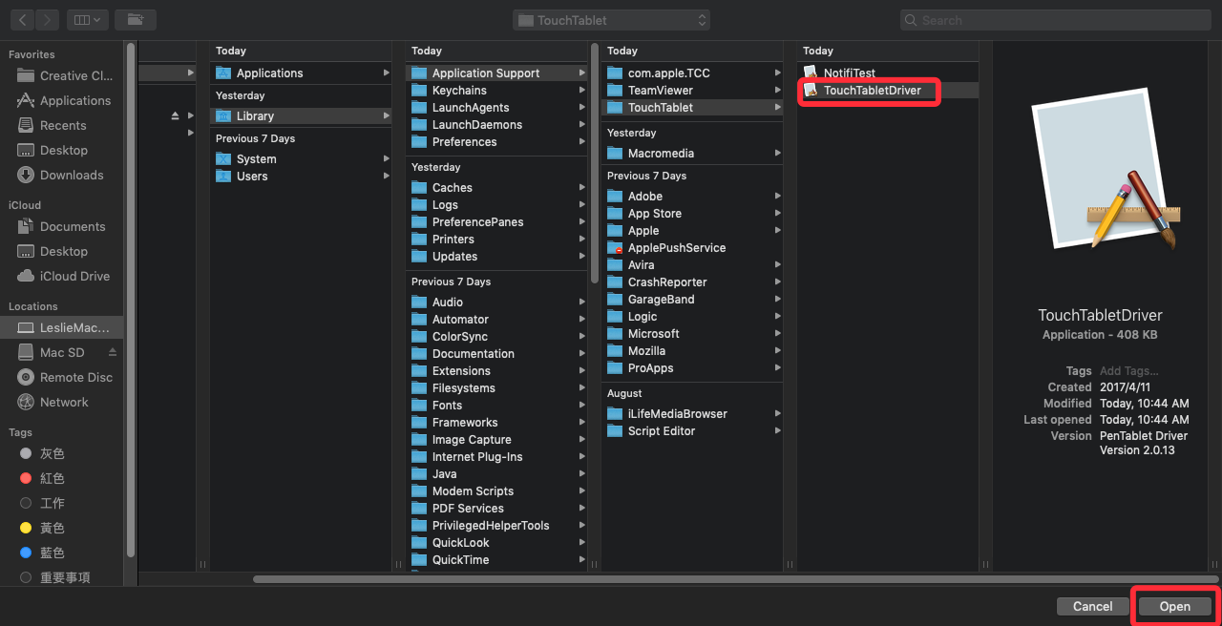

- Make sure “TabletSetting” and “TochTabletDriver” are both enabled.

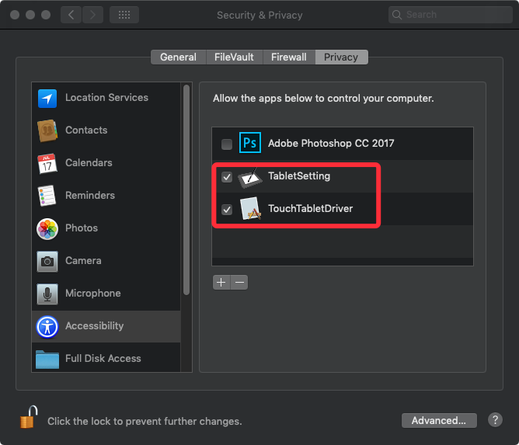

- If yes, close “Security & Privacy”.
- Open the “PenTabletSetting” on Launchpad and then set up your tablet to your preferences.

